**SQL Server**

**Assignment 1**

A Nageswar Rao

1. Create database of name STUDENT.
2. **Create table StudentInfo with following column:datatype**

**--StudentID: int , StudentName: varchar, ParentName: varchar, Contact: bigint, DOB:date, Address: varchar**

CREATE TABLE Student_Info(StudentId number,

StudentName varchar(120),

ParentName varchar(120),

Contact number,

DOB DATE,

Address varchar(180)

);

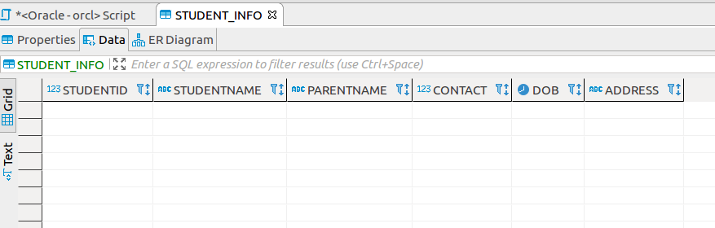

1. **Create table courseInfo with following column:datatype**

**CourseID: varchar, CourseName: varchar, Duration:varchar, faculty:varchar**

CREATE TABLE Course_Info(CourseId varchar(80),

CourseName varchar(80),

Duration varchar(20),

Faculty varchar(40));

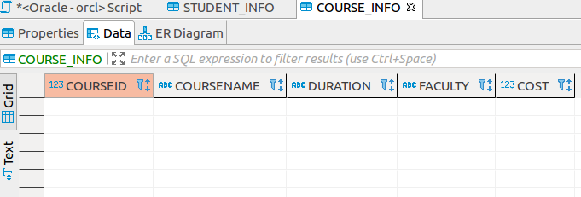

**4.Alter a table: courseInfo and add a column: Cost with datatype money - Number(10,4).**

ALTER TABLE Course_Info ADD AddCost NUMBER (10,4);

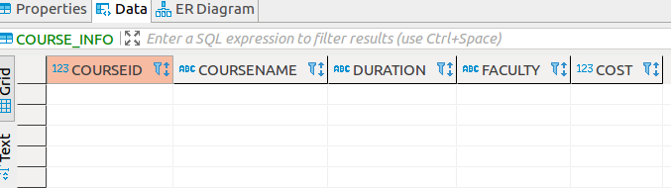

**5. Alter a table: courseInfo and modify the datatype of column: CourseID to int.**

ALTER TABLE Course_Info MODIFY CourseId int;

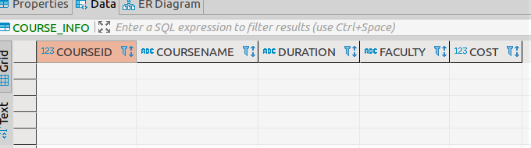

6. **Alter a table: StudentInfo and add a column: Gender with data type char.**

ALTER TABLE STUDENT_INFO ADD Gender char(1) CHECK (Gender IN ('M', 'F'));

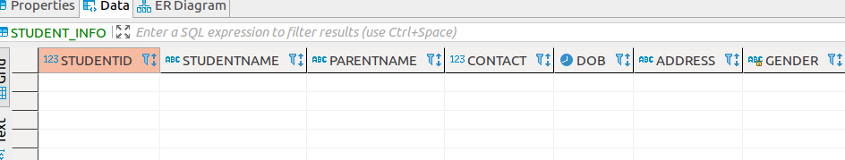

**7. Alter a table: StudentInfo and delete a column ParentName.**

ALTER TABLE Student_Info DROP COLUMN ParentName;

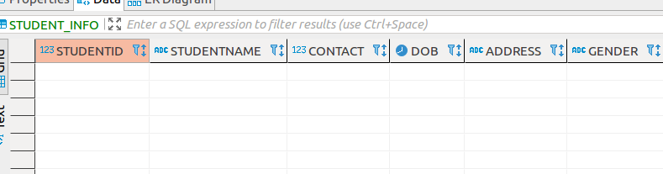

**8. Insert following data into table StudentInfo.**

**StudentID StudentNamne Contact DOB Address Gender**

**1 Alex 6657565656 06-05-2020 HYD M**

**2 Vishnu 7789876543 06-05-2020 Chennai M**

**3 Geetha 7788677656 06-05-2020 BZA F**

INSERT ALL

INTO Student_Info(StudentId,StudentName,Contact,DOB,Address,Gender) VALUES (1,'alex',6657565656,TO DATE('06.05.2020','DD.MM.YYYY'),'Hyd', 'M')

INTO Student_Info(StudentId,StudentName,Contact,DOB,Address,Gender) VALUES (2,'vishnu',7789876543,TO DATE('06.05.2020','DD.MM.YYYY'),'Chennai', 'M')

INTO Student_Info(StudentId,StudentName,Contact,DOB,Address,Gender) VALUES (3,'geetha',7789876543,TO DATE('06.05.2020','DD.MM.YYYY'),'BZA', 'F')

SELECT *FROM dual;

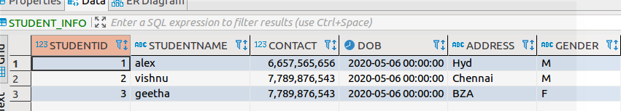

**9.Insert following data into table courseInfo.**

**CourseID CourseName Duration faculty Cost**

**1 React 1 Month Shameer 5000**

**2 BigData 5 weeks Seshank 10000**

**3 Python 3 weeks Sridhar**  10000

INSERT ALL

INTO Course_Info(CourseId,CourseName,Duration,Faculty,Cost) VALUES ('1','React','1 Month','Shameer', 5000)

INTO Course_Info(CourseId,CourseName,Duration,Faculty,Cost) VALUES ('2','BigData','5 Months','Seshank', 10000)

INTO Course_Info(CourseId,CourseName,Duration,Faculty,Cost) VALUES ('3','Python','3 weeks','Sridha',10000)

SELECT *FROM dual;

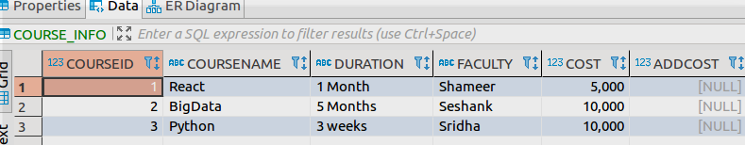

**10. Delete column from StudentInfo**

DELETE FROM Student_Info;

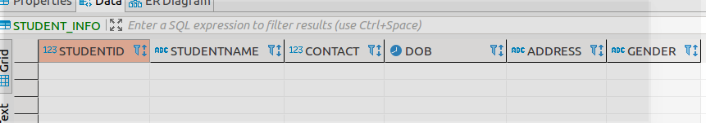

11) Drop a table StudentInfo.

DROP TABLE Student_Info;

